Reviewed on (Date):  Reviewed by: | Reviewed on (Date):  Reviewed by: | Reviewed on (Date):  Reviewed by: | Reviewed on (Date):  Reviewed by:
Approved on (Date):  Approved by: | Approved on (Date):  Approved by: | Approved on (Date):  Approved by: | Approved on (Date):  Approved by:

1.0 Purpose

The purpose of this procedure is to provide for a system and instructions, and to assign responsibilities for the control of PCL documents, data and records pertinent to the Management Systems implemented at PCL including but not limited to ISO 9001, ISO 45001, ISO14001, FSSC 22000 and ISO 50001,fssc,brc

2.0 Process Owner:

Manager EHS is the process owner of this procedure. He/She is responsible to:

- Ensure effective implementation of this procedure.
- Ensure that the procedure remains updated and available to all concerned.

MR in this procedure refers to the Manager EHS.

3.0 Scope

2.0 SCOPE:
This procedure will cover all departments of Packages Convertors Limited under the scope of Quality Management System.
3.0 ABBREVIATIONS:
MD: Managing Director
HOP: Head of Packaging
HOCD: Head of Consumer Division
MR: Management Representative
BUM: Business Unit Manager
IMS: Intigrated Management System
QP: Quality Plan
ISP: Integrated Systems Procedure

- LEVEL OF DOCUMENTS:
Level One: It includes the IMS Manual for IMS (If necessary) and ISO Standard.
Level Two: It includes the IMS Procedures, Quality Plans and List of interested parties.
Level Three: It includes;
- Work instructions/ Communication Matrix / Monitoring, Measurement & Analysis Matrix.
  - Job Descriptions
  - Product Specifications
  - Organogram
  - Process Flow Charts
  - External documents and standards
  - Specific SOPs
  - Specific Plans
  - Document Circulation List
  - Quality Record List
  - Process Specifications
  - Technical Specifications
  - Quality Risk Assessment
  - External/Internal Issues

Level Four: It includes Quality Records / Forms.

- DEFINITIONS:

COMMON PROCEDURE
Those procedures which are applicable to all departments of Packages Convertors limited.
DOCUMENTS
Relating to the BUFP, BUFC, BUCP and Service Departments. Shall include the IMS Manual if required, IMS procedures, Quality Plans, work instructions, Job Descriptions, reference specifications and IMS records referred to in the Quality System procedures.

CONTROLLED DOCUMENTS
Documented Information which require proper authorization from relevant approval authority. Intranet controlled documents carry a footer stating, “This is a controlled document of Packages Convertors Limited”. This footer also states the issuer name and last printed date and time to comply with the sunset clause (Annexure 2).

SUNSET CLAUSE
All documented informations if printed from their soft copies shall carry the date and time of that print. According to the Sunset Clause these documented informations will become void at end of that day and Packages Convertors Limited shall not be held accountable or responsible for any annotations expressed in that document.

UNCONTROLLED DOCUMENTS
These are photocopies of controlled documented informations issued by the authorized persons to personnel for reference. The document will be stamped and signed by the issuing authority.

OBSOLETE DOCUMENTS:

A documented information is said to be Obsolete when;
A) The documented information is revised the old version becomes invalid or void.
B) The documented information is declared invalid by the document control authority.

The obsolete document shall be stamped obsolete and will be taken off the intranet. However a record in hard form or in computers shall be maintained with the concerned department for at least one year in case of level 1 and 2 documents. Level 3 obsolete documents shall be maintained for 1 year/ or as mentioned in DCL while records once obsolete must be destroyed immediately (there retention times are mentioned in their record lists).

DOCUMENT CIRCULATION LIST (DCL):
A list showing all the updated documents of level 3 available in the respective department with their circulation.

QUALITY RECORD LIST:
List carrying all the quality records, its numbers and retention time.

INTRANET WEBSITE:
Packages convertors official website http://intranet.packages.com.pk/intranet_packages/
Share drive link Document Management System - BUFC LEVEL 2, 3 and 4 DOCUMENTS - All Documents (sharepoint.com)

READ ONLY:
These are rights given to user for accessing document just for the purpose of viewing. They cannot be changed, deleted or modified in any way on the intranet website.

Email Circulation:
Circulation that carries e-mails to all concerned persons of Packages Convertors Ltd. This can only be accessed, but change can be made with the permission of MR / or representative for communicating any changes or additions on the intranet website.

6.0 OVERALL RESPONSIBILITY:
The overall responsibility of the procedure lies with the Management/DMR Representative/Manager EHS.

7.0 PROCEDURE:

S.NO | ACTIVITY | RESPONSIBILITY
7.1 | DOCUMENTED INFORMATION CREATING
 | Document Format  All documented information created for IMS should carry the standard packages Convertors format (Annexure 1).  It should carry the following information:  - Document type  - Title of document  - Document number  - Document date  - Revision number  - Issued by (if issued document)  - Signatures of approving authority  - Page number and total pages  - End of Document identification  - Four years review history only on first page | Deptt. Managers / Business Unit Managers
 | For soft copies all documented informations shall be in MS office. The font size 12, Times new Roman, margin sizes 1 for all sides and A4 paper will be preferred.  All documented informations shall be written in English, however approved documents/ translations can be made in URDU where seen necessary.  In level 2 documents, use of amendment history form in the end of document will be appreciated. | Deptt. Managers / Business Unit Managers
7.2 | CONTROL OF DOCUMENTED INFORMATION
 | IMS documented information will be approved according to following criteria:  - Level One Document …… MD/ HOP & HOCD  - Level Two Document...… MR/ Respective Manager  - Level Three Documents … Respective Manager  - Level Four Documents …. Respective Manager | Deptt. Managers / Business Unit Managers
 | The approval authority shall sign the documented information in the “Approved by” column. Level 1 needs only revision month and year. In case of level 2 and 3 document date shall be the date when it got approved and document numbering shall be done according to document numbering work instruction “WIQA/4.2.3/01”. When a document will be signed by approval authority, it will be considered as control document however external documents will be stamped as “Control Document”. | MR/  Deptt. Managers / Business Unit Managers
7.3 | DOCUMENTED INFORMATION ISSUANCE / DISTRIBUTION
 | Level-1 & level-2 documents: The original copy of documented information (that need to be uploaded on the intranet website) will be sent to MR/DMR in approved hard form and soft form along with an Issuance request/ Revision form. The issuance request may be in hard form or e-mail.Level 3 scanned documents along with DCL will be shared to MR/DMR to be uploaded on intranet website  MR/ representative (after receiving hard and soft copies) will send soft copy to ERP representative with in a week for uploading on IMS intranet website.  ERP representative will upload the procedure on intranet after adding the footer as per Annexure 2 according to sunset clause.  ERP representative will make sure that these uploaded documents shall be read only.  Only MR/ representative are authorized to send documents for uploading on intranet. | MR/ ERP Manager  Deptt. Managers / Business Unit Managers
 | A communication will be launched through E-mail to all concerned departments about the newly uploaded documents. | MR
 | Level 3 and 4 documents: that are not going to be uploaded shall be issued and controlled by their respective Department Managers and issuance record shall be maintained against them. The documented information shall be stamped issued with date and signatures of the issuing authority. The document operative date shall be the date it has been issued according to the circulation list.  Editable versions of Level 2,3 and level 4 documents along with DCL and quality record list will be uploaded on document management system share drive, only by authorized persons of each BU, any amendments in documents will be automatically communicated to MR/DMR departmental head through email.He/She will review/note changes immediatly. Each BU representative will send scan of every changes document to MR/DMR through email to be uploaded on intranet. Share drive documents have amendment history and controlled users only after approval of MR/DMR When a documented information is issued from one department to another department and the department (To whom it was issued) have to use the same document in different areas then that department will internally copy the issued document, sign with name & date at front page of each copy and distribute it for use. That distributing department will also maintain its distribution record and when its revised issued copy received (from document custodian department); the previously internally distributed (obsolete) signed copies will be collected from all areas and disposed off. | Deptt. Managers / Business Unit Managers
7.4 | REVIEW OF DOCUMENTED INFORMATION
IMS documented information for level 2 and 3 shall be subjected to review by the potential users of the document for its operative capability on annual basis and signed on front page for four years after that it is scanned again and upload on intranet . This will also take place because of change in the process or as a result of corrective actions raised during internal audits. The changes shall be made according to the procedure. The revision number and date will only change in case of changes in SOP otherwise revision number will remain same.
In case of any change of signing authority of person at same position at any level, documents of level 2,3 and 4 are again signed and reviewed by new departmental head,BUM,AM,DMR/MR etc and controlled as per document control procedure. Revision of document will remain same
7.5 | DOCUMENTED INFORMATION UPDATING
 | Changes in Header/ Footer Format or minor cutting in Level 1 will not consider as revision. The department manager will inform the MR/ DMR of his intention to change Level 2 documents within his authority.  For minor changes in level 3 & 4 the relevant authority will sign at every cutting in document and for major changes they will revise the document according to given procedure.  Revision of document will not be changed if name of signing authority in header is changed | Deptt. Managers / Business Unit Managers
 | The revised Level 2 document checked and approved by its respective authority should be sent to the MR along with the issuance request. The master copy of the documented information shall be in record with the MR while the old version will be stamped obsolete and immediately taken off the website once the new version is uploaded. The MR shall than communicate to concerned personnel about the new document or the email as per requirement. The MR/DMR shall upload the document on the intranet website with a date on that file signifying its date of effectiveness. | Deptt. Managers / Business Unit Managers
 | For Level 3 and 4 documents that are revised shall be issued by its controlling authority according to its DCL. The old master copy of quality record shall be taken back by the approving authority and will be filed in the obsolete document file till its retention period expires. | Deptt. Managers / Business Unit Managers
 | Whenever there is a need for temporary instructions, the Department Managers can issue these instructions on display for machines but they don’t have to be stamped controlled. Issuance record is not mandatory for such instructions. | Deptt. Managers / Business Unit Managers
 | If a documented information is revised such that its revision number changes or a new document is added then a revised scan of Document Circulation List shall be sent to the MR/ DMR. | Deptt. Managers / Business Unit Managers
 | Amendments of documented information are not allowed by hand in any of the document of Quality & Lab Management System. | Deptt. Managers / Business Unit Managers
7.6 | IDENTIFICATION OF CHANGES
 | CHANGES DONE IN THE LEVEL-1, LEVEL-2 AND LEVEL-3 DOCUMENTS SHALL BE IN BOLD LETTERS. | Deptt. Managers / Business Unit Managers
 | If level 1, 2, or 3 documents are amended in any way such that its revision number changes it will be called a revised document. The date of the revision approval shall be written in the date column of the document control format of each page.  Any Changes only in the header and footer of the document (except document number) shall not constitute a change in revision number if the main content of the document has not been altered as such. | MR / DMR  Deptt. Managers / Business Unit Managers
 | In case of records / Form (level-4) the revision number shall be written along with revised date on top right of the form / record where applicable. | Deptt. Managers / Business Unit Managers
7.7 | OBSOLETE DOCUMENTED INFORMATION
 | If or when a document for level 1 and 2 is revised or considered void the master copy of that document shall be stamped obsolete by MR/DMR and filed in the obsolete documents file if required. The obsolete documents shall be immediately taken of the intranet website. For level 3 and 4 procedures when a document is revised its previous controlled copy will be stamped as “Obsolete” and will be kept in a separate file (if required). When new copies of revised document will be issued with in or to other department then previous obsolete copies also collected and disposed off. | MR/DMR  Deptt. Managers / Business Unit Managers
7.8 | EXTERNAL DOCUMENTS
 | The Department Manager shall control international standards and other external documents. They can be issued in their original format or that of packages Convertors standard format as copies or originals. All such issues will be stamped controlled and will be treated as level three documents. Their distribution will be according to their respective DCL or email. The date of their issuance by the external body, name of external body and revision no. (If any) shall also be identified in respective document circulation lists or issuance requisition. | MR/DMR  Deptt. Managers / Business Unit Managers
 | On revision of external documents issued by the department manager, the old original copy of the external document shall be stamped obsolete. If any standard is extracted from a book that standard shall also be stamped “obsolete” in the book (if it is not valid elsewhere in the department). | Deptt. Managers / Business Unit Managers
7.9 | BACK UP OF DATA
 | Data is backed up daily as per routine in the ERP Department.  Soft copies of Level 3 and Level 4 will be maintained by respective departments as back up on share drive. | ERP Manager  Deptt. Managers / Business Unit Managers
7.10 | CONTROL OF RECORDS
 | Records are evidence of conformity of IMS requirements. Records can be maintained in hard or soft form.  Records shall be  - Identifiable  - Indexed  - Legible  - Stored safely  - Easily retrievable  - Protected to damage  - Disposed off in a proper way | Deptt. Managers / Business Unit / Divisional Managers
 | A Quality Record List shall be prepared by relevant department and a copy will be set to MR as a reference.  Record name, number (if available) and retention period will be mentioned in Quality Record List. | Deptt. Managers / Business Unit / Divisional Managers
 | Technical records including record of original observations, derived data shall be retained for audit purpose. Records shall include identity of personnel responsible for sampling, testing and verification / approval of test results. | Deptt. Managers / Business Unit / Divisional Managers
 | When mistakes occur in records, it shall be crossed out, not erased, made illegible or deleted, and correct value entered alongside. | Deptt. Managers / Business Unit / Divisional Managers

8.0 ASSOCIATED DOCUMENTS:
- DOCUMENT CIRCULATION LISTS (DCL).
- QUALITY RECORD LIST

Annexure 1 (HEADER)

PACKAGES CONVERTORS LIMITED | Document type:  _________________________________________  Title:

Written by | Approved by | PAGE | REV | DATE | DOC NO.

Annexure 2 (FOOTER)

This is a controlled document of Packages Convertors Limited.

Last printed 07/03/24 9:27:00 AM(SSC Applied) Issued By: MR/DMR

REVIEW HISTORY
Four years Review history will be added only on first page of all level 2 and 3 procedures/WI/SOPS etc and documents shall be reviewed on yearly basis

Reviewed on (Date):  Reviewed by: | Reviewed on (Date):  Reviewed by: | Reviewed on (Date):  Reviewed by: | Reviewed on (Date):  Reviewed by:
Approved on (Date):  Approved by: | Approved on (Date):  Approved by: | Approved on (Date):  Approved by: | Approved on (Date):  Approved by:
Annexure 1 for BUFP
Following below Header, footer and review history format will be followed by BUFP

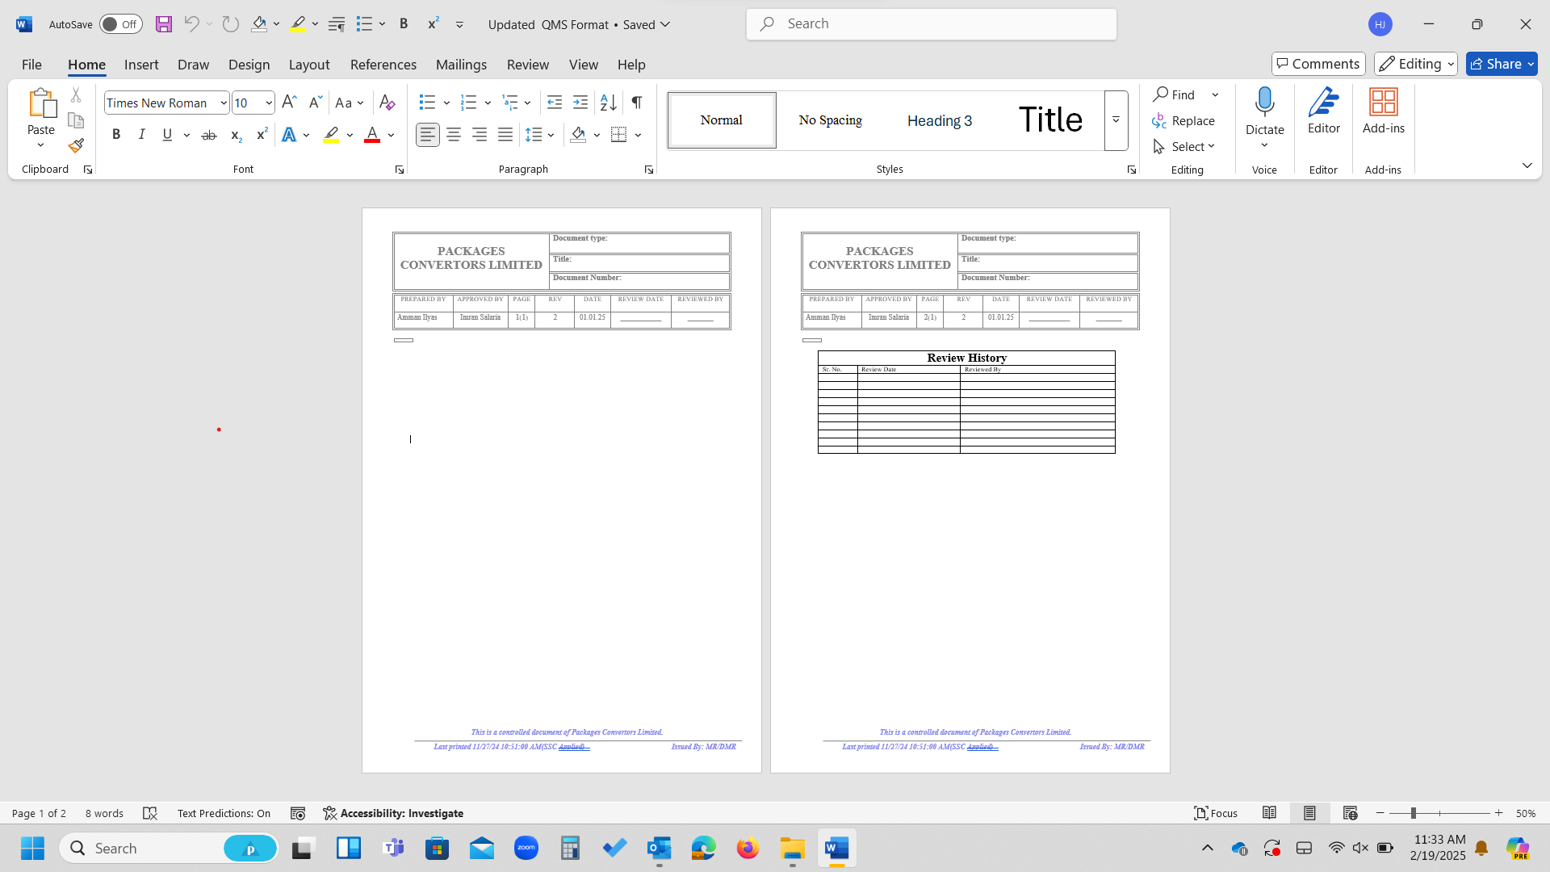

AMENDMENT HISTORY

REV # | DATE | PART/ SECTION | NATURE OF AMENDMENT | DONE BY
1 | September 2013 | Section 4, 5, 7.1, 7.2, 7.3, 7.6 & 7.7 | Simplifying the control and issuance system and improve effectiveness of procedure. | Asadullah Khan
2 | November 2014 | Section 1, 2, 4, 7.1, 7.4, 7.5, 7.10 &  End of Document | To include Lab Management System ISO 17025 requirements in this level 2 procedure | Asadullah Khan
3 | January  2017 | Section 7.2 | Changing in approval authority of Level 1 documents | Ayesha Khalid
4 | September 2017 | Section 3 and 4 | Addition of new requirement of ISO 9001:2015 in Level 2 and Level 3 documents. | Ayesha Khalid
5 | January 2018 | All | Harmonization with clause 7.5 by incorporating the new terms in SOP | Ayesha Khalid
6 | July 2024 | Front page | Incorporation of review history changes as per bat audit requirements | Hina

End of Document

